
WEBSITE

GROUP 3

MARIA MANZINI
ST10489157
CRAZY STORE PROPOSAL
07 APRIL 2025
WEDE 5020

Executive Summary

The proposal is to create a new website for Crazy Store, an e-commerce store in South Africa. The site will facilitate shopping online, increase customer satisfaction, and increase sales.

Company Overview
Crazy Store is a South African online shopping store that offers diversified products ranging from electronics, kitchen and home appliances, fashion products, and beauty products. Crazy Store was started 27 years ago and has become a renowned shopping store in South Africa which offers unique and cute.

Vision and Mission Statement

Vision of Crazy Store is to become South Africa's number one online store with a variety of products at affordable prices. The mission of the company is to provide quality customer services, speedy delivery, and secure online shopping.

Target Audience

Target market of Crazy Store is South African and international online consumers who would like to enjoy an affordable and convenient online shopping experience. The target market includes customers and businesses that would like to purchase products online at their convenience without having to directly visit the store.The objective of the new site is to provide an easy-to-use, safe, and rewarding customer online shopping experience. The website aims are to:

- Increase sales by 20% within the first year and are bound to rapidly increase as time goes by.

- Increase customer satisfaction ratings by 15% within the first six months and attract new customers worldwide.

- Increase website traffic by 30% within the first six months.

Current Website Analysis

The existing website has a variety of strengths, including:

- Easy-to-use navigation and search feature

- Extensive product range that tells consumers which products are available in store and which ones are unavailable online.

- Fair and affordable prices for products.

The existing website also has a variety of weaknesses, including:

- - Dated layout and design

- - Restricted to in store shopping only

- Their search engines are relatively slow and take time to load some products for customers to view.

Areas for Improvement

Based on the above mentioned deficiencies, areas for improvement have been identified as:

- Re-design website structure and appearance to make it more modern and user-friendly

- Introduce online purchasing functionality to allow customers to shop more easily

- Improve page loading speeds to improve customer experience

Features and Functionality Suggested for New Website

The new website will include the following features and functionality:

- - Shopping site with online payment gateway for secure payment

- - Product reviews and ratings

- - Customer account management

- - Order tracking and status

- - Mobile and tablet responsiveness

Online Shopping

Online shopping is crucial for Crazy Store, as this allows customers to purchase from the comfort of their homes. Online shopping also provides customers with access to more variety of goods to choose from and makes it convenient for customers to compare prices.

Design and Branding

The new site will be user-friendly and well-designed according to Crazy Store's brand identity. The brand colors of the company will be used, and it will be simple to use.

Color Scheme

- Primary color:

Typography

- Font family: Sans-sherrif font

- Font size: Headings:30-36 px
Text:16 px

Wireframes

Wire-frames will be created to depict the website structure and information architecture.

The following programming languages and frameworks will be used to develop the website:

- - HTML will be used for the basic structure of the website for the insertions of images and links and navigation's as well.

- - CSS will be used for styling and the color scheme of the website to make it visually appealing for customers.

- - JavaScript will be used to establish the website and ensure its functional for all users.

Timeline and Milestones

The timeline and milestones for the project are as follows:

- Week 1-2: Research and planning where we will gather all the resources needed for the website

- Week 3-4: Design and wire framing is where we will use HTML codes to design the websites basic structure and ensure that it is compatible with different browsers,

- Week 5-6: Front-end development is where we will check if the website is user friendly and is operational for consumers to use.

- Week 7-10: Back-end development,testing and quality assurance is where we will test if the website is actually implementing what the consumer had told it to do and if it performs tasks to ensure that consumers needs are met.

- Week 11: Launching the website to the public for use.

Budget

The budget for the development, hosting, and maintenance of the website is as follows:

- Development: R 50,000
Whereby we will gather all the resources needed for the website and we will use HTML codes to design the websites basic structure and ensure that it is compatible with different browsers,

- Hosting: R 5,000 per annum

- Maintenance: R 10,000 per annum for checking if the website is user friendly and is operational for consumers to use.This is where quality assurance will come in where we will test if the website is actually implementing what the consumer had told it to do and if it performs tasks to ensure that consumers needs are met.

Sitemap
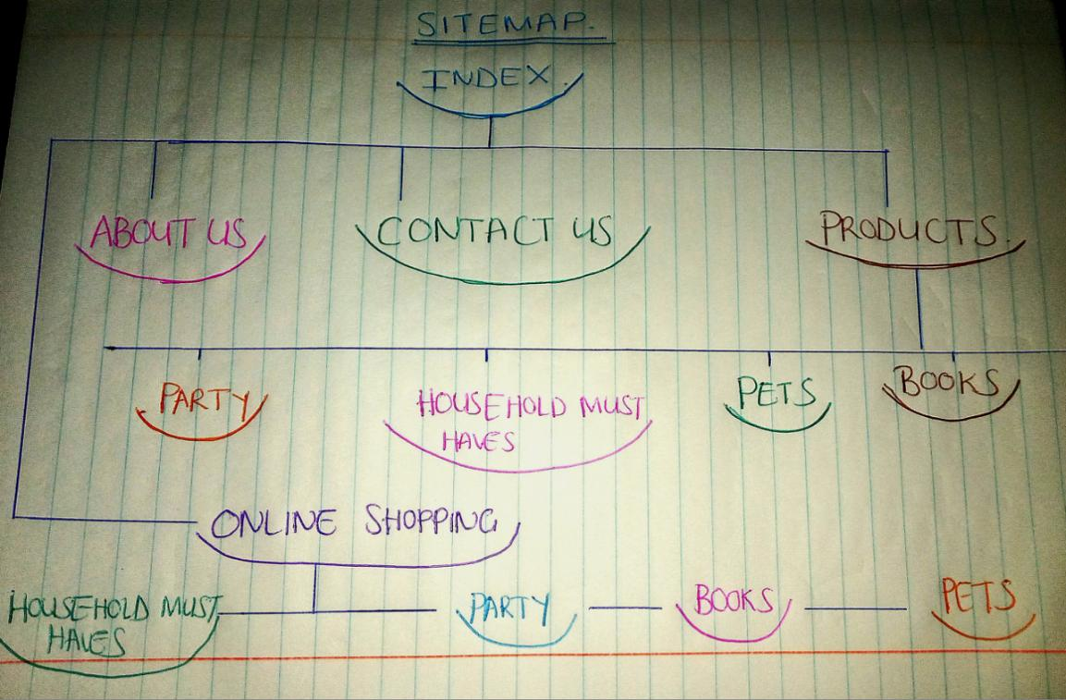

References
Logo image: According to google.com ([s.n]).([n.d]).logo PNG FILE.225x225.crazy store website logo image

According to Nielsen, J.2000. Designing Web Usability. Peachpit Press.peachpit press

The Independent Institution of Education(IIE),2025.WEDE5020POE.([n.t]).[online via student materials]The Independent Institution of Education.Available at:<WEDE5020POE.DOX
>[accessed date 18 March 2025]

